Bruce James Beggs ISO, B Sc
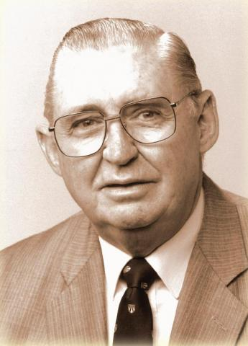Bruce Beggs was born in Dwellingup on 2 February 1928 where his father (James Beggs) was a sleeper cutter and timber gatherer or faller who after service in the First World War joined the Field Staff Division of the Forests Department. Bruce attended the government school in Dwellingup and later at Kirup before going on to Bunbury High School and the Christian Brothers’ College in St Georges Terrace, Perth.
His first employment was with the Forest Department as a fifteen year old during the Second World War and he went on to obtain a Bachelor of Science at the University of Western Australia and a Diploma in Forestry at the Australian Forestry School in Canberra. After graduation in 1950, he commenced work with the Forests Department of Western Australia on 1 March 1951 at Pemberton where his early tasks included assessment of timber volumes in the forest as well as quarantine inspections of imported timber buildings to prevent the introduction of the Sirex Wasp, a serious pine tree pest.
He married in 1954, was appointed as Officer in Charge of Dwellingup and then Divisional Officer Level One before transferring to Manjimup in October 1960. He describes the events leading up to the Dwellingup fire which was started by lightning on 20 January 1961 and how it led to the devastation of the town.
Whilst at Manjimup he became Divisional Forest Officer Grade II, Divisional Forest Officer and Senior Divisional Forester which he feels was the best position he ever had. Following this he became an Inspector and a Superintendent transferring from Manjimup to Perth in 1966 as a Chief of Division where he was responsible for fires and safety. He was appointed Conservator of Forests in 1972.
He got involved with the setting up of the woodchip industry which he felt would utilise the forest material that couldn’t be used for other purposes. He mentions the conflicts and legal battles between the Forests Department and the conservation movement and the resulting polarisation of attitudes that occurred over the management of the old growth forests, the evolving need for multiple uses of forest areas in general and the requirements of the mining industry.
He mentions the changes in communications technology, the techniques used for spotting fires and the introduction of aircraft for fire spotting and fire management as well as prescribed planned burning of the forests to reduce fuel loads and fire risk, aerial photography and mapping and the management of jarrah dieback disease and the resulting forest quarantine restrictions.
He also mentions the need for improvements in safety standards and success in achieving this.
In 1983 he commenced in the position of Director General at the Department of the Premier and Cabinet under the then Premier, the Hon. Brian Burke, and served in that role until his retirement.
Obituary in “The West Australian” 22.4.2013
When the ferocious bushfires tore through Dwellingup in January 1961, Bruce Beggs acted quickly to ensure no lives were lost.
The devastating fires struck the WA forests department stronghold early in Mr Beggs' career, but colleagues have hailed him a hero for the role he played in defending the town and evacuating surrounding towns that were later razed.
The long-time public servant, who was WA's last conservator of forests before he became director-general of the Department of Premier and Cabinet, died on Friday aged 85 after a long battle with Parkinson's disease.
Mr Beggs grew up surrounded by jarrah forest in Dwellingup and followed in his forester father's footsteps when he began work with the then WA Forests Department in 1951.
His career culminated in his appointment as Conservator of Forests.
After more than a decade in the role he accepted an offer from then premier Brian Burke to head the Department of Premier and Cabinet.
He was awarded an Imperial Service Order and recognised by his profession with Australia's highest forestry award, the Jolly Medal by the Institute of Foresters of Australia.
Former Department of Conservation and Land Management General Manager Roger Underwood, whose career overlapped with Mr Beggs' for almost 30 years and who counted him among his friends in later years, said Mr Beggs saw the department as "a family" and the welfare of its staff was always of paramount importance.
He said he regarded Mr Beggs to be the "hero of the Dwellingup fire".
"Just as he expected his staff to support him, he would support them to the death," Mr Underwood said.
"We all looked up to him with great respect."
Frank Campbell, a former public sector commissioner and close friend of Mr Beggs who also played a key role in battling the Dwellingup fires, said he expected Mr Beggs would be recognised and remembered very specially by many people.
He said Mr Beggs "did all the good things a good general would do" during the Dwellingup fires.
Mr Beggs' eldest daughter Anne Priestman recalled a wise and loving father who was always helping people and loved picnics in the bush.
Mr Beggs is survived by his wife Betty, daughters Lee White, Kaye Thorn and Ms Priestman, nine grandchildren and a great-granddaughter.

